THREE PHASE SOLID STATE RELAY WITH ZVS

ABSTRACT

The project is designed for a three phase solid state relay system. It incorporates three single phase units where each phase is controlled individually by a power triac with RC snubber network for zero voltage switching.
Opto-isolators are used for each phase to receive switching signals from a microcontroller of PIC family. Loads are connected in series with a set of triacs being driven by the opto-isolator. The microcontroller is designed to generate output pulses after zero voltage pulse to ensure that the load is getting switched on at zero cross of the supply waveform. The zero crossing feature of the TRIAC driver, (an opto-isolator) ensures low noise generation thus avoiding sudden inrush of current on resistive and inductive loads. Here in this project we are using two push buttons for generating output pulses from the microcontroller randomly, not coinciding with zero voltage supply voltage of the waveform. Using a CRO or a DSO we can see the waveform of the voltage supplied to the load for verifying the switching of the load at the zero voltage point.
Further the project can be enhanced by using 2 back to back SCRs, in each phase for heavy load switching as used in industries. Over load and short circuit protection can also be incorporated for higher reliability.

BLOCK DIAGRAM
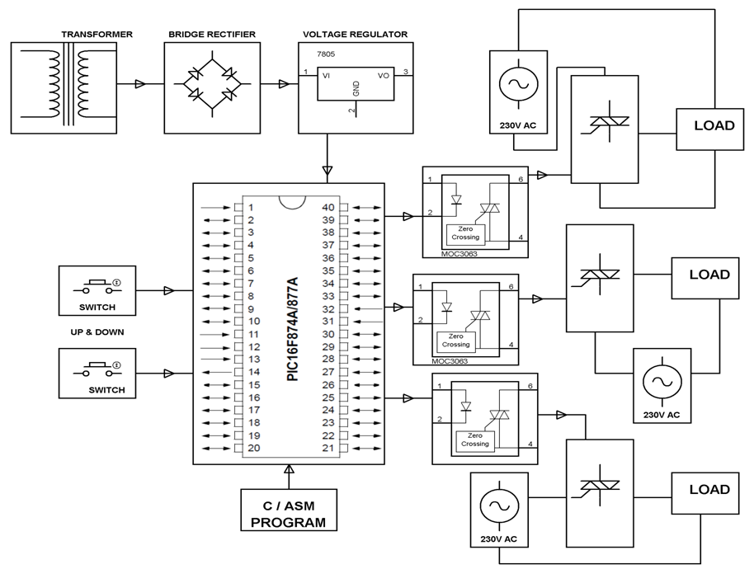
HARDWARE REQUIREMENTS:

PIC series Microcontroller, Opto-isolator, Triacs, Transformers, Diodes, voltage regulator, push button, LED, Resistors, Capacitors, Crystal, Lamp

SOFTWARE REQUIREMENTS:

HI-TECH PICC Tool suite
Languages: Embedded C or Assembly

